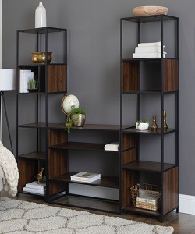

Modern bookcase

$109.08

Availability: In stock

**Description:**

This Gurley Corner Unit Bookcase offers a stylish way to add function to any space. The shelf is specifically designed for easy placement in corners and features five open shelves that are ideal for display and storage of pictures, plants and other household items. The shelves have a natural wood finish that is lacquer sealed for protection and durability. A dark antique silver metal frame adds an industrial flair and completes this versatile piece.